Carlin and Soskice: The 3-Equation Model from First Principles
Adam Butlin (University of Oxford) · 6 October 2026
These notes derive Carlin and Soskice’s IS curve, Phillips curve and monetary rule from the decisions of households, firms, wage setters and the central bank, following the appendices of their textbook. The last section uses the three equations to solve for the economy’s response to shocks.

1. The IS curve: the demand side

1.1 Consumption
A household values utility U from consumption C in every period from t onwards. β is the discount factor, a number between 0 and 1 that measures how much the household values next period relative to this one. Utility one period ahead is weighted by β, utility two periods ahead by β², and so on. If the household knew its future consumption, its lifetime utility V_{t} would be:
$$V_{t}=U\left(C_{t}\right)+βU\left(C_{t+1}\right)+β^{2}U\left(C_{t+2}\right)+β^{3}U\left(C_{t+3}\right)+…$$
The summation sign Σ writes the same sum compactly. Read Σ_{s=0}∞ as: set s = 0, 1, 2, … in turn, compute β^{s}U(C_{t+s}) for each value, and add up the results. The term for s = 0 is U(C_{t}), since β⁰ = 1:
$$V_{t}=\sum_{s=0}^{∞}{β^{s}}U\left(C_{t+s}\right)$$
In practice future consumption is uncertain, so the household weights each possible outcome by its probability. E_{t} denotes this expectation, formed with the information available in period t. Suppose, for example, that next period’s consumption will be high, C^{H}, with probability ρ, and low, C^{L}, with probability 1 − ρ. Expected utility next period is then the probability-weighted sum:
$$E_{t}\left[U\left(C_{t+1}\right)\right]=ρ⋅U\left(C^{H}\right)+(1−ρ)⋅U\left(C^{L}\right)$$
With more possible outcomes the sum has more terms, but the idea is the same. Lifetime expected utility applies an expectation to each future period. Today’s consumption C_{t} is already known, so it needs none:
$$V_{t}=U\left(C_{t}\right)+βE_{t}\left[U\left(C_{t+1}\right)\right]+β^{2}E_{t}\left[U\left(C_{t+2}\right)\right]+…$$
The expectation of a sum is the sum of the expectations, so the same expression can be written with one expectation outside the summation sign:
 | $$V_{t}=E_{t}\left[\sum_{s=0}^{∞}{β^{s}}U\left(C_{t+s}\right)\right]$$ | (1.1)
It starts period t with financial assets B_{t}, which earn the real interest rate r, and receives post-tax income Y_{t}. What it consumes plus the assets it carries into next period cannot exceed its income plus its assets with interest:
 | $$C_{t}+B_{t+1}=Y_{t}+\left(1+r\right)B_{t}$$ | (1.2)
The household chooses the assets it carries into next period, B_{t+1}. Use (1.2) to write consumption this period and next in terms of assets, substitute both into lifetime utility (1.1), and differentiate with respect to B_{t+1}. Saving one more unit lowers C_{t} by 1 and raises C_{t+1} by (1 + r). The terms after the second do not involve B_{t+1}. The last line is the Euler equation:
 | $$\begin{matrix}V_{t} & =U\left(\underset{C_{t}}{\underbrace{Y_{t}+\left(1+r\right)B_{t}−B_{t+1}}}\right) \\ & +βE_{t}\left[U\left(\underset{C_{t+1}}{\underbrace{Y_{t+1}+\left(1+r\right)B_{t+1}−B_{t+2}}}\right)\right]+… \\ \frac{∂V_{t}}{∂B_{t+1}} & =−U′\left(C_{t}\right)+β\left(1+r\right)E_{t}\left[U′\left(C_{t+1}\right)\right]=0 \\ U′\left(C_{t}\right) & =β\left(1+r\right)E_{t}\left[U′\left(C_{t+1}\right)\right]\end{matrix}$$ | (1.3)
In words: the utility lost by saving one more unit today equals the expected discounted utility gained from (1 + r) more units next period. Assume log utility, no uncertainty about the future, and β(1 + r) = 1, so that the interest rate exactly offsets the household’s impatience. Consumption is then the same in every period:
 | $$\begin{matrix}U′\left(C\right) & =\frac{1}{C} \\ \frac{1}{C_{t}} & =β\left(1+r\right)⋅\frac{1}{C_{t+1}} \\ C_{t+1} & =C_{t} \\ C_{t+s} & =C_{t} \text{for every }s\end{matrix}$$ | (1.4)
To find the level of consumption, iterate the budget constraint forward. Solve (1.2) for today’s assets (first line). Move it forward one period (second line) and substitute that into the first (third and fourth lines). Repeating the substitution an infinite number of times gives the fifth line. The limit term is zero by assumption: the household cannot run a Ponzi scheme, rolling over its debt forever without repaying it. Multiplying by (1 + r) and rearranging gives the lifetime budget constraint in the last line:
 | $$\begin{matrix}B_{t} & =\frac{1}{1+r}\left(C_{t}−Y_{t}+B_{t+1}\right) \\ B_{t+1} & =\frac{1}{1+r}\left(C_{t+1}−Y_{t+1}+B_{t+2}\right) \\ B_{t} & =\frac{1}{1+r}\left[C_{t}−Y_{t}+\frac{1}{1+r}(C_{t+1}−Y_{t+1}+B_{t+2})\right] \\ B_{t} & =\frac{1}{1+r}\left(C_{t}−Y_{t}\right)+{\left(\frac{1}{1+r}\right)}^{2}\left(C_{t+1}−Y_{t+1}+B_{t+2}\right) \\ B_{t} & =\sum_{s=0}^{∞}{\frac{C_{t+s}−Y_{t+s}}{{\left(1+r\right)}^{s+1}}}+\underset{=0\text{ (no-Ponzi condition)}}{\underbrace{\lim_{s→∞}\frac{B_{t+s+1}}{{\left(1+r\right)}^{s+1}}}} \\ \sum_{s=0}^{∞}{\frac{C_{t+s}}{{\left(1+r\right)}^{s}}} & =\left(1+r\right)B_{t}+\sum_{s=0}^{∞}{\frac{Y_{t+s}}{{\left(1+r\right)}^{s}}}\end{matrix}$$ | (1.5)
In words: the present value of lifetime consumption equals assets with interest plus the present value of lifetime income. Future income is not known in period t, and the household is assumed to plan on its expected value as if it were certain. Let Ψ_{t} be assets with interest plus the expected present value of future income. Put constant consumption from (1.4) into (1.5), using the sum of a geometric series:
 | $$\begin{matrix}Ψ_{t} & ≡\left(1+r\right)B_{t}+E_{t}\left[\sum_{s=1}^{∞}{\frac{Y_{t+s}}{{\left(1+r\right)}^{s}}}\right] \\ C_{t}\sum_{s=0}^{∞}{\frac{1}{{\left(1+r\right)}^{s}}} & =Ψ_{t}+Y_{t} \\ \sum_{s=0}^{∞}{\frac{1}{{\left(1+r\right)}^{s}}} & =\frac{1}{1−\frac{1}{1+r}}=\frac{1+r}{r} \\ C_{t} & =\frac{r}{1+r}\left(Ψ_{t}+Y_{t}\right)\end{matrix}$$ | (1.6)
This is the permanent income consumption function: the household spends the annuity value of its lifetime wealth. For example, if the interest rate is 4%, then r/(1 + r) = 0.04/1.04 ≈ 0.038. A one-off windfall of £1,000 raises Y_{t} by £1,000, so the household spends only about £38 of it this period. It saves the rest and spends the same £38 extra in every later period out of the interest.
To connect (1.6) to the IS curve, use a hybrid consumption function. A share σ of households follow the permanent income hypothesis (PIH) and consume according to (1.6), with post-tax income Y_{t} = (1 − t)y, where y is output and t the tax rate. The rest are hand-to-mouth (HTM) and spend all their income:
 | $$\begin{matrix}C^{PIH} & =\frac{r}{1+r}\left[Ψ_{t}+\left(1−t\right)y\right] \\ C^{HTM} & =\left(1−t\right)y \\ C & =σC^{PIH}+\left(1−σ\right)C^{HTM} \\ C & =\underset{c_{0}}{\underbrace{σ\frac{r}{1+r}Ψ_{t}}}+\underset{c_{1}}{\underbrace{\left[σ\frac{r}{1+r}+\left(1−σ\right)\right]}}\left(1−t\right)y \\ C & =c_{0}+c_{1}\left(1−t\right)y\end{matrix}$$ | (1.7)
Since r/(1 + r) is small, the marginal propensity to consume c₁ is close to the share of hand-to-mouth households. Lifetime wealth enters only through autonomous consumption c₀.

1.2 Investment: Tobin’s Q
A firm produces output F(K) from capital K. The marginal product of capital F′(K) is positive and falls as K rises. Capital bought in period t is used from period t + 1 and wears out at the depreciation rate δ, and a unit of capital costs one unit of output. The firm chooses investment I to maximise the present value of profits, output less investment, subject to the law of motion for capital:
 | $$\begin{matrix}V_{t} & =\sum_{s=0}^{∞}{\frac{F\left(K_{t+s}\right)−I_{t+s}}{{\left(1+r\right)}^{s}}} \\ K_{t+1} & =\left(1−δ\right)K_{t}+I_{t}\end{matrix}$$ | (1.8)
As with the household, substitute the constraint for investment and differentiate, here with respect to next period’s capital K_{t+1}. It appears only in this period’s investment and in next period’s output and investment, so later terms drop out. The derivative is the discounted benefit of one more unit of capital less its cost of 1:
 | $$\begin{matrix}V_{t} & =F\left(K_{t}\right)−\underset{I_{t}}{\underbrace{\left[K_{t+1}−\left(1−δ\right)K_{t}\right]}} \\ & +\frac{1}{1+r}\left[F\left(K_{t+1}\right)−\underset{I_{t+1}}{\underbrace{\left(K_{t+2}−\left(1−δ\right)K_{t+1}\right)}}\right]+… \\ \frac{∂V_{t}}{∂K_{t+1}} & =−1+\frac{F′\left(K_{t+1}\right)+1−δ}{1+r}=0\end{matrix}$$ | (1.9)
Tobin’s Q writes (1.9) as a ratio. One more unit of capital costs 1 today. Next period it yields its marginal product plus the undepreciated 1 − δ of the unit. Q is the discounted benefit over the cost, and (1.9) says the firm invests until Q = 1. A higher r lowers Q:
 | $$\begin{matrix}MB & =\frac{F′\left(K_{t+1}\right)+1−δ}{1+r} \\ MC & =1 \\ Q & ≡\frac{MB}{MC}=\frac{F′\left(K_{t+1}\right)+1−δ}{1+r}\end{matrix}$$ | (1.10)
Set Q = 1 in (1.10) to find the desired capital stock K*, at which the marginal product of capital just covers its user cost, the interest and depreciation on a unit of capital. To see how K* responds to the interest rate, differentiate this condition with respect to r. The marginal product falls as capital rises, F″(K) < 0, so a higher r means a smaller K*:
 | $$\begin{matrix}Q & =\frac{F′\left(K^{*}\right)+1−δ}{1+r}=1 \\ F′\left(K^{*}\right) & =r+δ \\ F″\left(K^{*}\right)\frac{dK^{*}}{dr} & =1 \\ \frac{dK^{*}}{dr} & =\frac{1}{F″\left(K^{*}\right)}<0\end{matrix}$$ | (1.11)
Investment is what takes capital to K* next period, so by the law of motion it falls with r as well. The only assumption needed is diminishing returns to capital. For example, with F(K) = AK^{α} and 0 < α < 1, F″(K) = α(α − 1)AK^{α−2} < 0.
For a straight-line IS curve, replace the marginal product by its tangent line at the current capital stock K̄, a first-order Taylor approximation. This defines n₀ and n₁:
 | $$\begin{matrix}F′\left(K\right) & ≈F′\left(\overset{‾}{K}\right)+F″\left(\overset{‾}{K}\right)\left(K−\overset{‾}{K}\right) \\ F′\left(K\right) & ≈\underset{n_{0}}{\underbrace{\left[F′\left(\overset{‾}{K}\right)−F″\left(\overset{‾}{K}\right)\overset{‾}{K}\right]}}−\underset{n_{1}}{\underbrace{\left[−F″\left(\overset{‾}{K}\right)\right]}}K \\ F′\left(K\right) & ≈n_{0}−n_{1}K\end{matrix}$$ | (1.12)
Put this into F′(K*) = r + δ and use the law of motion. The steeper the fall in the marginal product (the larger n₁), the less K* and investment respond to r:
 | $$\begin{matrix}n_{0}−n_{1}K^{*} & =r+δ \\ K^{*} & =\frac{n_{0}−δ−r}{n_{1}} \\ I_{t} & =K^{*}−\left(1−δ\right)K_{t} \\ I_{t} & =\underset{a_{0}}{\underbrace{\left[\frac{n_{0}−δ}{n_{1}}−\left(1−δ\right)K_{t}\right]}}−\underset{a_{1}}{\underbrace{\frac{1}{n_{1}}}}r \\ I_{t} & =a_{0}−a_{1}r\end{matrix}$$ | (1.13)
This is the investment function. Higher expected profitability (a higher n₀) raises a₀, and investment falls by a₁ for each unit rise in the real interest rate.

1.3 The multiplier and the IS curve
Output y is spent on consumption C, investment I and government spending G:
 | $$y=C+I+G$$ | (1.14)
Put in the hybrid consumption function (1.7) and solve for y. The fraction 1/[1 − c₁(1 − t)] multiplying autonomous spending is the multiplier:
 | $$\begin{matrix}y & =c_{0}+c_{1}\left(1−t\right)y+I+G \\ y\left[1−c_{1}\left(1−t\right)\right] & =c_{0}+I+G \\ y & =\frac{c_{0}+I+G}{1−c_{1}\left(1−t\right)}\end{matrix}$$ | (1.15)
Put in the investment function (1.13). The last line is the IS curve, with autonomous demand A and interest sensitivity a:
 | $$\begin{matrix}y & =\frac{c_{0}+a_{0}−a_{1}r+G}{1−c_{1}\left(1−t\right)} \\ y & =\underset{A}{\underbrace{\frac{c_{0}+a_{0}+G}{1−c_{1}\left(1−t\right)}}}−\underset{a}{\underbrace{\frac{a_{1}}{1−c_{1}\left(1−t\right)}}}r \\ y & =A−ar\end{matrix}$$ | (1.16)
The multiplier scales the interest sensitivity as well as autonomous demand: a higher rate cuts investment by a₁, and the lost income cuts consumption in turn. A rise in autonomous demand shifts the IS curve up by ΔA/a:
 | $$\begin{matrix}r & =\frac{A−y}{a} \\ Δr|_{y\text{ fixed}} & =\frac{ΔA}{a}\end{matrix}$$ | (1.17)
Spending plans take time to change. Investment projects are ordered and financed in advance, and households on fixed-rate loans face a new rate only when they refinance. So the interest rate set in period 0 affects output in period 1:
 | $$y_{1}=A−ar_{0}$$ | (1.18)
The lag matters for policy: the central bank cannot offset a shock in the period it arrives, and must forecast one period ahead.
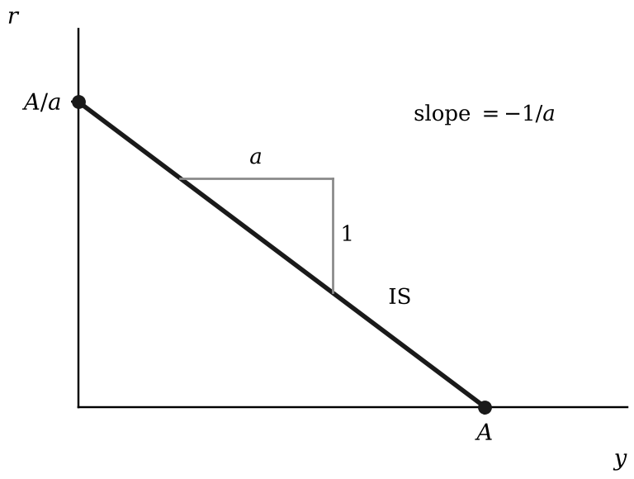
Figure 1. The IS curve, y = A − ar. It meets the output axis at A and the interest rate axis at A/a. A one-point rise in r lowers output by a, so the slope is −1/a.

2. The Phillips curve: the supply side

2.1 Labour demand under perfect competition
A competitive firm sells output at price P and hires labour L at the money wage W. With capital K fixed and production function f, its profit Π is:
 | $$Π=P⋅f\left(L;K\right)−W⋅L$$ | (2.1)
Choose L. The partial derivative of f with respect to L is the marginal product of labour MPL:
 | $$\begin{matrix}\frac{∂Π}{∂L} & =P⋅MPL−W=0 \\ P⋅MPL & =W \\ \frac{W}{P} & =MPL\end{matrix}$$ | (2.2)
This is the labour demand curve. In a competitive labour market, employment is where it crosses the labour supply curve, so the real wage equals both the MPL and the wage at which the last worker is willing to work.
The model departs from this on both sides. Firms with market power pay a real wage below the MPL (Section 2.3), and the wage needed to motivate workers is above the wage at which they are willing to work (Section 2.4). At the competitive level of employment, the wage that wage setting requires is therefore above the MPL, and the wage that price setting allows is below it. Because the wage-setting wage falls as employment falls and the price-setting wage does not, the two are reconciled only at lower employment.

2.2 The mark-up and the elasticity of demand
A firm facing a downward-sloping demand curve has profit equal to revenue minus cost C(y):
 | $$Π=P\left(y\right)⋅y−C\left(y\right)$$ | (2.3)
Choose output y, using the product rule on revenue. MC is marginal cost:
 | $$\begin{matrix}\frac{∂Π}{∂y} & =P+y\frac{∂P}{∂y}−\frac{∂C}{∂y}=0 \\ P+y\frac{∂P}{∂y} & =MC \text{(marginal revenue equals marginal cost)} \\ P\left(1+\frac{y}{P}\frac{∂P}{∂y}\right) & =MC \text{(factor out }P\text{)}\end{matrix}$$ | (2.4)
Use the elasticity of demand η, defined as a positive number:
 | $$\begin{matrix}η & ≡−\frac{∂y}{∂P}\frac{P}{y} \\ \frac{y}{P}\frac{∂P}{∂y} & =−\frac{1}{η} \\ P\left(1−\frac{1}{η}\right) & =MC\end{matrix}$$ | (2.5)
The mark-up on price μ is the gap between price and marginal cost as a share of price:
 | $$\begin{matrix}\frac{MC}{P} & =1−\frac{1}{η} \\ \underset{μ}{\underbrace{\frac{P−MC}{P}}} & =1−\frac{MC}{P}=\frac{1}{η} \\ μ & =\frac{1}{η}\end{matrix}$$ | (2.6)
The mark-up on marginal cost μ_{C} is the same gap as a share of marginal cost:
 | $$\begin{matrix}P & =\frac{η}{η−1}MC \\ \underset{μ_{C}}{\underbrace{\frac{P−MC}{MC}}} & =\frac{η}{η−1}−1=\frac{1}{η−1} \\ μ_{C} & =\frac{1}{η−1}\end{matrix}$$ | (2.7)
The two are linked exactly:
 | $$\frac{1}{1+μ_{C}}=\frac{1}{1+\frac{1}{η−1}}=\frac{η−1}{η}=1−\frac{1}{η}=1−μ$$ | (2.8)

2.3 The price-setting real wage
Capital is fixed in the short run, as in Section 2.1, so labour is the only input the firm can vary. One more unit of output needs 1/MPL more workers, and marginal cost is:
 | $$MC=\frac{W}{MPL}$$ | (2.9)
Put this into (2.5), written with the mark-up on price:
 | $$\begin{matrix}P\left(1−μ\right) & =\frac{W}{MPL} \\ \frac{W}{P} & =MPL\left(1−μ\right)\end{matrix}$$ | (2.10)
With capital fixed, the MPL would normally fall as employment rises. The book simplifies by taking it as constant at λ, output per worker, over the range that matters. The price-setting (PS) real wage w^{PS} is then a horizontal line:
 | $$\begin{matrix}MPL & =λ \\ w^{PS} & =\frac{W}{P}=λ\left(1−μ\right)\end{matrix}$$ | (2.11)

2.4 The wage-setting curve
Effort cannot be observed, so the wage w must make working at least as good as shirking. Over a horizon of h weeks, a worker who works gets w less the cost of effort c. A shirker gets w for the s weeks until caught, then the reservation wage w_{r}. Setting the two payoffs equal gives the lowest wage that deters shirking:
 | $$\begin{matrix}h\left(w−c\right) & =sw+\left(h−s\right)w_{r} \\ \left(h−s\right)w & =\left(h−s\right)w_{r}+hc \\ w & =w_{r}+c+\frac{s}{h−s}c\end{matrix}$$ | (2.12)
The reservation wage is what a fired worker expects: the benefit b for the share τ of the horizon spent unemployed, and the going wage less effort for the rest. Substitute into (2.12) and solve for the wage-setting real wage w^{WS}:
 | $$\begin{matrix}w_{r} & =τb+\left(1−τ\right)\left(w−c\right) \\ w & =τb+\left(1−τ\right)\left(w−c\right)+c+\frac{s}{h−s}c \\ τw & =τb+τc+\frac{s}{h−s}c \\ w^{WS} & =b+c+\frac{1}{τ}⋅\frac{s}{h−s}c\end{matrix}$$ | (2.13)
Employment enters the wage-setting real wage only through τ. When employment is higher, a fired worker finds a new job sooner, so τ is lower and the wage in (2.13) is higher:
 | $$\frac{∂w^{WS}}{∂τ}=−\frac{1}{τ^{2}}⋅\frac{s}{h−s}c<0$$ | (2.14)
Losing the job costs less, so a higher wage is needed to deter shirking, and the wage-setting (WS) curve slopes up. A higher benefit or cost of effort shifts the whole curve up. Equilibrium output y_{e} is the level at which the wage-setting real wage equals the price-setting real wage.
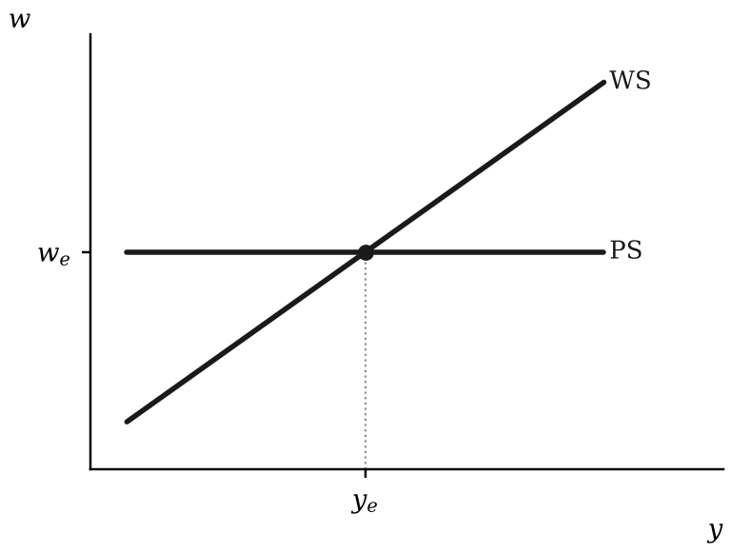
Figure 2. Wage setting and price setting. Equilibrium output is where the two curves cross.

2.5 The Phillips curve
Step 1, wage setting. At y_{e} wage setters accept the real wage that price setting delivers. Above y_{e} they seek a higher one. Let α be the proportional rise in the real wage they seek per unit of output gap, which is the proportional slope of the WS curve near equilibrium. Output is scaled so that y_{e} = 100, so a unit of output gap is 1 per cent of equilibrium output. That rise comes on top of the inflation they expect when wages are set, E_{t−1}[π_{t}]:
 | $$\begin{matrix}{\left(\frac{ΔW}{W}\right)}_{t}−E_{t−1}\left[π_{t}\right] & =α\left(y_{t}−y_{e}\right) \\ {\left(\frac{ΔW}{W}\right)}_{t} & =E_{t−1}\left[π_{t}\right]+α\left(y_{t}−y_{e}\right)\end{matrix}$$ | (2.15)
Step 2, expectations. Assume adaptive expectations: wage setters expect last period’s inflation to continue:
 | $$E_{t−1}\left[π_{t}\right]=π_{t−1}$$ | (2.16)
Step 3, price setting. By (2.7) and (2.9) with MPL = λ, the price is P = (1 + μ_{C})W/λ, so prices move in proportion to wages:
 | $$\begin{matrix}\frac{P_{t}}{P_{t−1}} & =\frac{\left(1+μ_{C}\right)W_{t}/λ}{\left(1+μ_{C}\right)W_{t−1}/λ}=\frac{W_{t}}{W_{t−1}} \\ \frac{P_{t}−P_{t−1}}{P_{t−1}} & =\frac{W_{t}−W_{t−1}}{W_{t−1}} \text{(subtract 1 from both sides)} \\ π_{t} & ={\left(\frac{ΔW}{W}\right)}_{t}\end{matrix}$$ | (2.17)
Step 4, combine (2.15), (2.16) and (2.17). The last line is the Phillips curve:
 | $$\begin{matrix}π_{t} & =E_{t−1}\left[π_{t}\right]+α\left(y_{t}−y_{e}\right) \\ π_{t} & =π_{t−1}+α\left(y_{t}−y_{e}\right)\end{matrix}$$ | (2.18)
Adaptive expectations do not mean there is no inflation target: the bank still aims at π^{T} in Section 3. They mean wage setters give the target no weight until they see inflation fall. This makes inflation persistent and makes bringing it down costly in output, as in the disinflations of the 1980s.
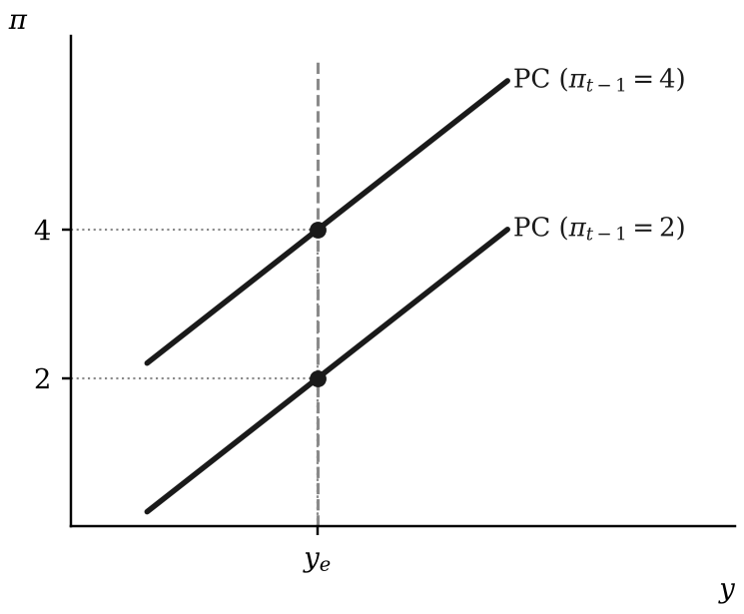
Figure 3. Phillips curves under adaptive expectations. Each passes through last period’s inflation at equilibrium output.

3. The monetary rule and the interest rate rule
Timing: by choosing r₀ the bank chooses y₁ and, through it, π₁.
 | $$r_{0}\overset{\text{IS, one-period lag}}{→}y_{1}\overset{\text{PC, same period}}{→}π_{1}, π_{0}\text{ given}$$ | (3.1)

3.1 The monetary rule (MR)
The book assumes the central bank’s loss function; it is not derived inside the model. Squaring makes deviations in either direction costly, and large ones much more so. The output target is assumed to be y_{e}, the only level at which inflation is constant. β here is the weight on inflation, as in the book, and is not the household’s discount factor from Section 1.1:
 | $$L={\left(y_{1}−y_{e}\right)}^{2}+β{\left(π_{1}−π^{T}\right)}^{2}$$ | (3.2)
Its constraint is the Phillips curve (2.18) for period 1:
 | $$π_{1}=π_{0}+α\left(y_{1}−y_{e}\right)$$ | (3.3)
Minimise with respect to y₁, using the chain rule. By (3.3), a unit rise in output raises inflation by α. The last line is the monetary rule (MR):
 | $$\begin{matrix}\frac{∂L}{∂y_{1}} & =2\left(y_{1}−y_{e}\right)+2β\left(π_{1}−π^{T}\right)\frac{∂π_{1}}{∂y_{1}}=0 \\ \frac{∂π_{1}}{∂y_{1}} & =α \\ \left(y_{1}−y_{e}\right) & =−αβ\left(π_{1}−π^{T}\right)\end{matrix}$$ | (3.4)
The bank accepts a larger output gap when each unit of output buys more disinflation (a higher α) or when it cares more about inflation (a higher β). Put the constraint (3.3) into the monetary rule to get the output gap rule, which gives the output gap in terms of inherited inflation π₀. Call the coefficient θ:
 | $$\begin{matrix}\left(y_{1}−y_{e}\right) & =−αβ\left(π_{0}+α\left(y_{1}−y_{e}\right)−π^{T}\right) \\ \left(y_{1}−y_{e}\right)\left(1+α^{2}β\right) & =−αβ\left(π_{0}−π^{T}\right) \\ \left(y_{1}−y_{e}\right) & =−\underset{θ}{\underbrace{\frac{αβ}{1+α^{2}β}}}\left(π_{0}−π^{T}\right) \\ \left(y_{1}−y_{e}\right) & =−θ\left(π_{0}−π^{T}\right)\end{matrix}$$ | (3.5)
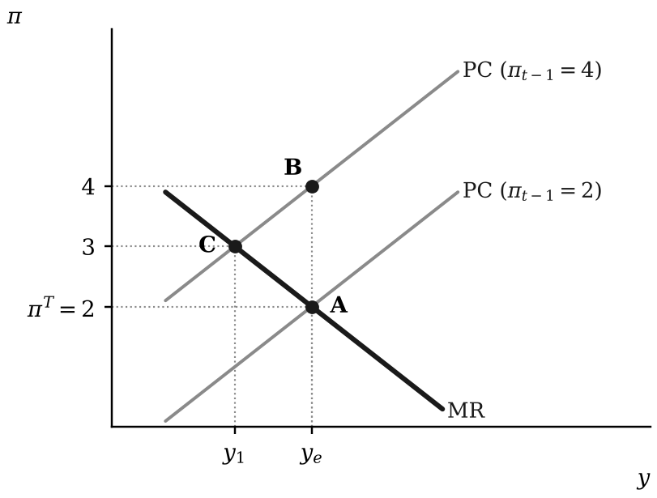
Figure 4. The monetary rule. With inherited inflation of 4 and a target of 2, the bank chooses point C (α = β = 1).

3.2 The IS curve in deviations and the Fisher equation
To reach that output gap the bank needs two more relations. The first is the IS curve (1.18). Subtract its equilibrium version, in which the stabilising rate r_{S} gives output y_{e}:
 | $$\begin{matrix}y_{1} & =A−ar_{0} \\ y_{e} & =A−ar_{S} \\ y_{1}−y_{e} & =−a\left(r_{0}−r_{S}\right)\end{matrix}$$ | (3.6)
The second links the real rate in the IS curve to the nominal rate i that the bank sets. One pound buys 1/P_{t} goods today; lent at i_{t}, it is expected to buy (1 + i_{t})/E_{t}[P_{t+1}] goods next period. The real return is their ratio, and expected inflation is the expected proportional rise in prices:
 | $$\begin{matrix}1+r_{t} & =\left(1+i_{t}\right)\frac{P_{t}}{E_{t}\left[P_{t+1}\right]} \\ E_{t}\left[π_{t+1}\right] & ≡\frac{E_{t}\left[P_{t+1}\right]−P_{t}}{P_{t}} \\ 1+r_{t} & =\frac{1+i_{t}}{1+E_{t}\left[π_{t+1}\right]} \\ r_{t} & =\frac{i_{t}−E_{t}\left[π_{t+1}\right]}{1+E_{t}\left[π_{t+1}\right]} \\ r_{t} & ≈i_{t}−E_{t}\left[π_{t+1}\right] \text{(when expected inflation is low)}\end{matrix}$$ | (3.7)
The last line is the Fisher equation: the real interest rate is approximately the nominal rate less expected inflation.

3.3 The interest rate rule
Put the IS curve in deviations (3.6) into the output gap (3.5). The result is the rule for the real interest rate, with coefficient φ:
 | $$\begin{matrix}−a\left(r_{0}−r_{S}\right) & =−θ\left(π_{0}−π^{T}\right) \\ r_{0}−r_{S} & =\underset{φ}{\underbrace{\frac{θ}{a}}}\left(π_{0}−π^{T}\right) \\ r_{0}−r_{S} & =φ\left(π_{0}−π^{T}\right)\end{matrix}$$ | (3.8)
Written out, φ = αβ/[a(1 + α²β)]. With a = α = β = 1, the real rate rises by 0.5 points for each point of inflation above target. Now use the Fisher equation (3.7) and adaptive expectations (2.16) to write the rule for the nominal rate. The stabilising nominal rate i_{S} is r_{S} plus the target:
 | $$\begin{matrix}i_{0} & =r_{0}+E_{0}\left[π_{1}\right] \\ E_{0}\left[π_{1}\right] & =π_{0} \\ i_{0} & =r_{0}+π_{0} \\ i_{S} & =r_{S}+π^{T} \\ i_{0}−i_{S} & =\left(r_{0}−r_{S}\right)+\left(π_{0}−π^{T}\right) \\ i_{0}−i_{S} & =\left(1+φ\right)\left(π_{0}−π^{T}\right)\end{matrix}$$ | (3.9)
In words: the bank moves the nominal rate one for one with inflation, and then by a further φ for each point of inflation above target.

3.4 The Taylor principle and the zero lower bound
By (3.9), the nominal rate rises by more than inflation does, so that the real rate rises. This is the Taylor principle. With a = α = β = 1, the nominal rate rises by 1.5 points per point of inflation.
The nominal rate cannot fall below zero, which puts a floor under the real rate:
 | $$\begin{matrix}i_{0} & =r_{0}+E_{0}\left[π_{1}\right]≥0 \\ minr_{0} & =−E_{0}\left[π_{1}\right]\end{matrix}$$ | (3.10)
The floor binds when the real rate that the rule (3.8) asks for lies below it:
 | $$r_{S}+φ\left(π_{0}−π^{T}\right)<−E_{0}\left[π_{1}\right]$$ | (3.11)
The bank then sets the nominal rate to zero, and output and inflation follow from the IS curve and the Phillips curve:
 | $$\begin{matrix}r_{0} & =−E_{0}\left[π_{1}\right] \\ y_{1}−y_{e} & =−a\left(r_{0}−r_{S}\right)=a\left(E_{0}\left[π_{1}\right]+r_{S}\right) \\ π_{1} & =E_{0}\left[π_{1}\right]+α\left(y_{1}−y_{e}\right)=E_{0}\left[π_{1}\right]+αa\left(E_{0}\left[π_{1}\right]+r_{S}\right)\end{matrix}$$ | (3.12)
If expected inflation plus the stabilising real rate is negative, output is below equilibrium and inflation comes in below what was expected. Under adaptive expectations, expected inflation then falls, the floor under the real rate rises, and output falls further. This is the deflation trap. It needs either a negative stabilising real rate, as after a large fall in demand, or expected deflation.

4. Shocks: the diagrams as algebra

4.1 One recipe for every shock
Every shock is handled with the output gap rule (3.5) and the interest rate rule (3.8). For each shock: find π₀ from the Phillips curve, find the new stabilising rate r_{S}′ from the IS curve, then apply the two rules.

4.2 An inflation shock
An inflation shock ξ shifts the Phillips curve up for one period:
 | $$\begin{matrix}π_{0} & =π^{T}+ξ \\ r_{S}′ & =r_{S} \\ y_{1}−y_{e} & =−θξ \\ r_{0}−r_{S} & =φξ \\ π_{1} & =π_{0}+α\left(y_{1}−y_{e}\right)=π^{T}+\left(1−αθ\right)ξ\end{matrix}$$ | (4.1)
With a = α = β = 1 and ξ = 2, as in Figure 5, θ = φ = 1/2. The bank raises the real rate by 1 point, opens an output gap of −1 and leaves inflation 1 point above target in period 1. Perhaps surprisingly, it does not aim to remove the shock at once: because both losses are quadratic, the last point of disinflation would cost more in lost output than it saves in inflation. The rule then applies again to the inflation the bank has inherited, so excess inflation shrinks by the factor 1 − αθ = 1/(1 + α²β) each period, from 4 to 3 to 2.5 in Figure 5.
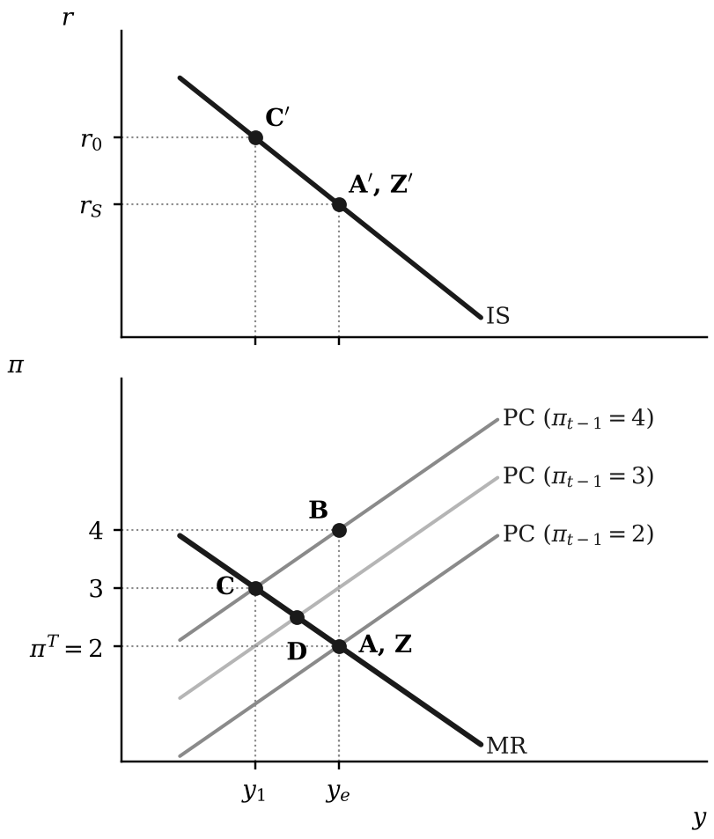
Figure 5. An inflation shock of 2 points (a = α = β = 1). The bank raises the rate to r₀, and the economy moves from B to C, D and back to Z.

4.3 A permanent demand shock
Demand rises by ΔA for good (a prime marks a value after the shock). The interest rate in period 0 is still r_{S}:
 | $$\begin{matrix}y_{0} & =A′−ar_{S}=\left(A−ar_{S}\right)+ΔA=y_{e}+ΔA \\ π_{0} & =π^{T}+α\left(y_{0}−y_{e}\right)=π^{T}+αΔA\end{matrix}$$ | (4.2)
The stabilising rate rises:
 | $$\begin{matrix}y_{e} & =A−ar_{S} \\ r_{S} & =\frac{A−y_{e}}{a} \\ y_{e} & =A′−ar_{S}′ \\ r_{S}′ & =\frac{A′−y_{e}}{a} \\ r_{S}′−r_{S} & =\frac{ΔA}{a}\end{matrix}$$ | (4.3)
Apply (3.5) and (3.8), using φ = θ/a:
 | $$\begin{matrix}y_{1}−y_{e} & =−αθΔA \\ r_{0}−r_{S}′ & =φαΔA=\frac{αθ}{a}ΔA \\ r_{0}−r_{S} & =\underset{\text{offset the shock}}{\underbrace{\frac{ΔA}{a}}}+\underset{\text{squeeze out inflation}}{\underbrace{\frac{αθΔA}{a}}}=\frac{\left(1+αθ\right)}{a}ΔA\end{matrix}$$ | (4.4)
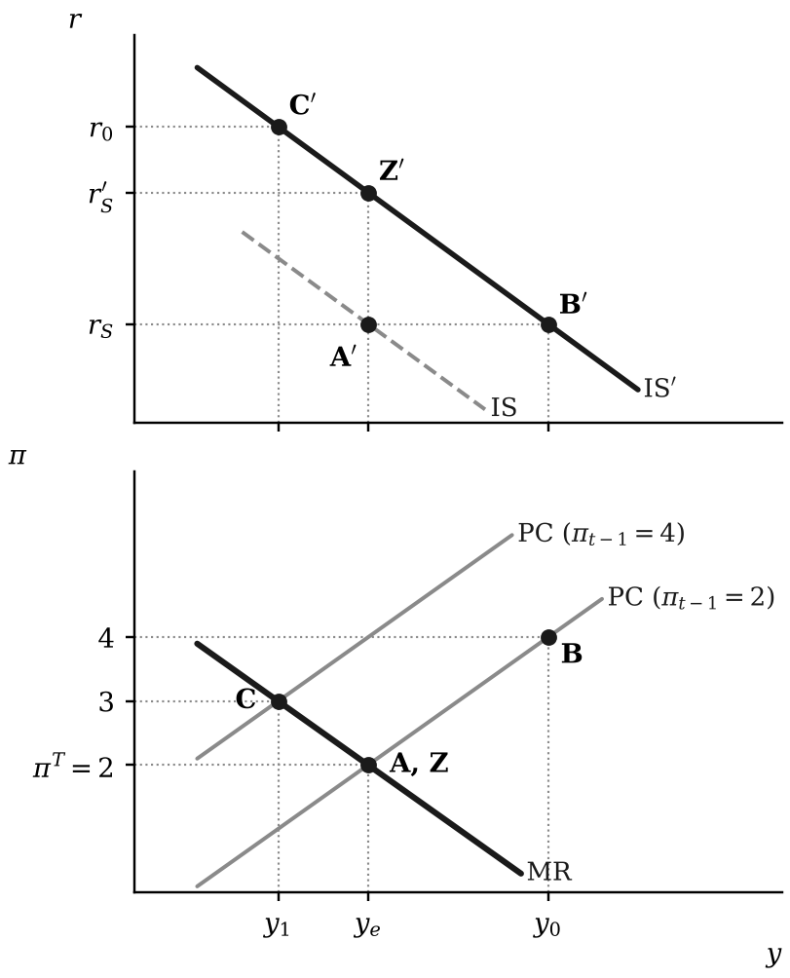
Figure 6. A permanent demand shock, ΔA = 2. The IS curve shifts up and the stabilising rate rises to r_{S}′.

4.4 A temporary demand shock
If the shock is expected to end, the stabilising rate is unchanged and only the second part remains:
 | $$r_{0}−r_{S}=φαΔA=\frac{αθ}{a}ΔA$$ | (4.5)

4.5 How the response depends on a
A flatter IS curve (higher a) needs a smaller rate change, because each point on the rate moves output further:
 | $$\begin{matrix}r_{0}−r_{S} & =\frac{\left(1+αθ\right)}{a}ΔA \\ \frac{∂\left(r_{0}−r_{S}\right)}{∂a} & =−\frac{\left(1+αθ\right)}{a^{2}}ΔA<0\end{matrix}$$ | (4.6)

4.6 How the response depends on α and β
The MR line is flatter with a higher α or a higher β:
 | $$\begin{matrix}\left(y_{1}−y_{e}\right) & =−αβ\left(π_{1}−π^{T}\right) \\ π_{1}−π^{T} & =−\frac{1}{αβ}\left(y_{1}−y_{e}\right)\end{matrix}$$ | (4.7)
A higher β always raises the output cut:
 | $$\frac{∂θ}{∂β}=\frac{α\left(1+α^{2}β\right)−αβ⋅α^{2}}{{\left(1+α^{2}β\right)}^{2}}=\frac{α}{{\left(1+α^{2}β\right)}^{2}}>0$$ | (4.8)
A steeper Phillips curve (a higher α) has two opposing effects, which is perhaps surprising. Each unit of output now removes more inflation, so less output is needed for a given disinflation; but disinflation is now cheaper, so the bank buys more of it. The first effect dominates, and a higher α lowers the output cut, only when α²β > 1:
 | $$\frac{∂θ}{∂α}=\frac{β\left(1+α^{2}β\right)−αβ⋅2αβ}{{\left(1+α^{2}β\right)}^{2}}=\frac{β\left(1−α^{2}β\right)}{{\left(1+α^{2}β\right)}^{2}}<0\text{ when }α^{2}β>1$$ | (4.9)

4.7 A supply shock
Equilibrium output rises by Δy_{e}. Demand is unchanged, so inflation falls:
 | $$\begin{matrix}y_{0} & =A−ar_{S}=y_{e} \\ y_{0}−y_{e}′ & =−Δy_{e} \\ π_{0} & =π^{T}+α\left(y_{0}−y_{e}′\right)=π^{T}−αΔy_{e}\end{matrix}$$ | (4.10)
The stabilising rate falls:
 | $$\begin{matrix}y_{e}′ & =A−ar_{S}′ \\ r_{S}′ & =\frac{A−y_{e}′}{a} \\ r_{S}′−r_{S} & =−\frac{Δy_{e}}{a}\end{matrix}$$ | (4.11)
Apply (3.5) and (3.8) around the new equilibrium:
 | $$\begin{matrix}y_{1}−y_{e}′ & =−θ\left(π_{0}−π^{T}\right)=αθΔy_{e}>0 \\ r_{0}−r_{S}′ & =φ\left(π_{0}−π^{T}\right)=−\frac{αθ}{a}Δy_{e} \\ r_{0}−r_{S} & =−\frac{Δy_{e}}{a}−\frac{αθΔy_{e}}{a}=−\frac{\left(1+αθ\right)}{a}Δy_{e}\end{matrix}$$ | (4.12)
The bank cuts the rate by more than the fall in the stabilising rate, pushing output above its new equilibrium so that inflation climbs back to target. After a positive demand shock output and inflation rise together; after a positive supply shock output rises and inflation falls.
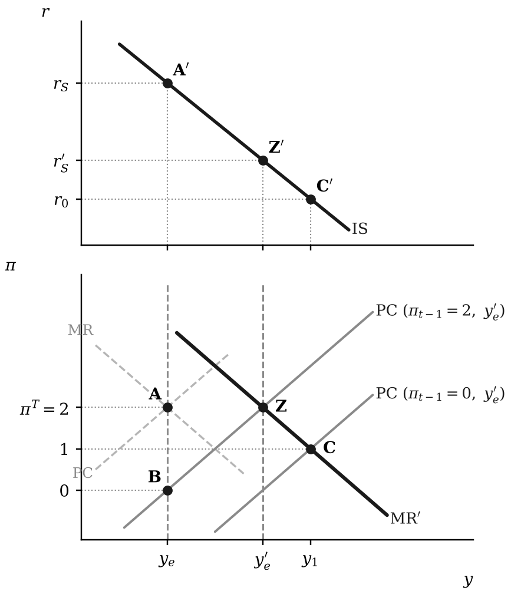
Figure 7. A positive supply shock, Δy_{e} = 2. Inflation falls from A to B, and the bank cuts the rate to reach C. Dashed lines show the curves before the shock.

4.8 Where a supply shock comes from
The PS curve shifts down by the proportion d and wage setting is unchanged. Let w_{e} be the real wage at the old equilibrium. Near it the wage-setting real wage rises by the proportion α per unit of output, as in Section 2.5. The new equilibrium y_{e}′ is where that line meets the lower PS wage:
 | $$\begin{matrix}w_{e}\left[1+α\left(y_{e}′−y_{e}\right)\right] & =w_{e}\left(1−d\right) \\ α\left(y_{e}′−y_{e}\right) & =−d \\ Δy_{e} & =−\frac{d}{α}\end{matrix}$$ | (4.13)
If wage setters accept the loss, the WS curve shifts down by the same proportion:
 | $$\begin{matrix}w_{e}\left(1−d\right)\left[1+α\left(y_{e}′−y_{e}\right)\right] & =w_{e}\left(1−d\right) \\ Δy_{e} & =0\end{matrix}$$ | (4.14)
Equilibrium output therefore falls only to the extent that wage setters resist the fall in the real wage.
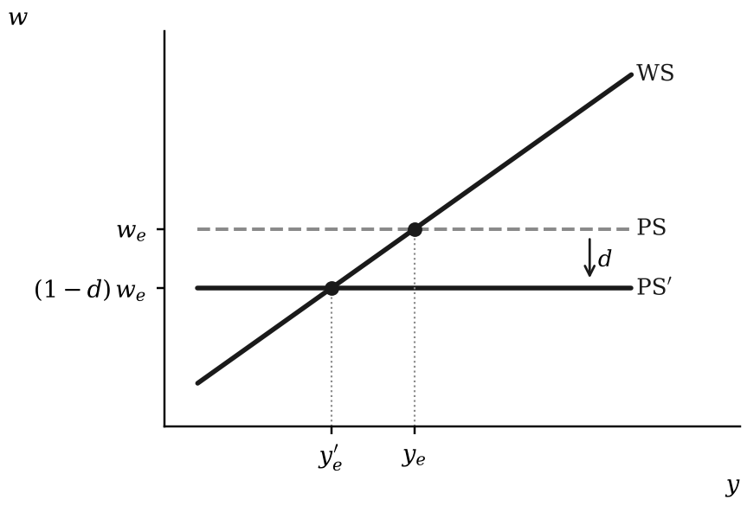
Figure 8. A proportional fall of d in the price-setting real wage lowers equilibrium output by d/α.

4.9 A credit crunch and an oil shock together
A credit crunch lowers autonomous demand (ΔA < 0). An oil shock lowers equilibrium output (Δy_{e} < 0) and raises inherited inflation. In any combination, the stabilising rate moves with demand relative to supply, and the rule adds a response to inherited inflation:
 | $$\begin{matrix}y_{e}′ & =A′−ar_{S}′ \\ r_{S}′−r_{S} & =\frac{\left(A′−y_{e}′\right)−\left(A−y_{e}\right)}{a}=\frac{ΔA−Δy_{e}}{a} \\ r_{0}−r_{S}′ & =φ\left(π_{0}−π^{T}\right) \\ r_{0}−r_{S} & =\underset{\text{demand relative to supply}}{\underbrace{\frac{ΔA−Δy_{e}}{a}}}+\underset{\text{inherited inflation}}{\underbrace{φ\left(π_{0}−π^{T}\right)}}\end{matrix}$$ | (4.15)
The bank raises the rate only if:
 | $$r_{0}>r_{S} \text{if and only if} φ\left(π_{0}−π^{T}\right)>\frac{Δy_{e}−ΔA}{a}$$ | (4.16)
When the credit crunch is large relative to the fall in equilibrium output, the right-hand side is positive, and the bank can cut the rate even though inflation is above target.

5. The open economy

5.1 The real exchange rate
Let e be the nominal exchange rate, the number of units of home currency needed to buy one unit of foreign currency, so that a rise in e is a depreciation of the home currency. P* is the foreign price level. A unit of foreign goods costs P* in foreign currency, or eP* in home currency. The real exchange rate ℰ (a script capital E) is the price of foreign goods in terms of home goods, and ε (lower-case epsilon) is its logarithm:
 | $$\begin{matrix}ℰ & ≡\frac{eP^{*}}{P} \\ ε & ≡ln ℰ=ln e+ln P^{*}−ln P \\ Δε & ≈\frac{Δe}{e}+π^{*}−π\end{matrix}$$ | (5.1)
A rise in ℰ is a real depreciation: home goods become cheaper relative to foreign goods. By the last line, the real exchange rate depreciates when the nominal rate depreciates or when home inflation π runs below foreign inflation π*. The script ℰ for the real exchange rate is distinct from the expectations operator E_{t}.

5.2 Net exports and the Marshall–Lerner condition
Let X be the volume of exports and M the volume of imports. Imports are foreign goods, so their cost in home goods is ℰM, and net exports measured in home goods are:
 | $$NX=X(ℰ)−ℰ⋅M(ℰ)$$ | (5.2)
A real depreciation raises export volumes and lowers import volumes, but it also raises the cost in home goods of every unit still imported. Which effect wins depends on the elasticities of export and import volumes with respect to ℰ, both defined as positive numbers:
 | $$\begin{matrix}η_{X} & ≡\frac{dX}{dℰ}\frac{ℰ}{X} \\ η_{M} & ≡−\frac{dM}{dℰ}\frac{ℰ}{M}\end{matrix}$$ | (5.3)
Differentiate (5.2) with respect to ℰ, using the product rule on the import bill, and multiply by ℰ/X. Starting from balanced trade, X = ℰM, gives the last line:
 | $$\begin{matrix}\frac{dNX}{dℰ} & =\frac{dX}{dℰ}−M−ℰ\frac{dM}{dℰ} \\ \frac{ℰ}{X}\frac{dNX}{dℰ} & =η_{X}−\frac{ℰM}{X}\left(1−η_{M}\right) \\ \frac{ℰ}{X}\frac{dNX}{dℰ} & =η_{X}+η_{M}−1\text{ (when }X=ℰM\text{)}\end{matrix}$$ | (5.4)
This is the Marshall–Lerner condition: a real depreciation improves the trade balance if and only if η_{X} + η_{M} > 1. Volumes respond to relative prices slowly, as contracts are renegotiated and buyers switch suppliers, so short-run elasticities are smaller than long-run ones. A depreciation can therefore worsen the trade balance at first and improve it later, the J-curve. The rest of this section assumes the condition holds.

5.3 The open-economy IS curve
Linearise net exports. They rise with the real exchange rate, by x₁ > 0 under the Marshall–Lerner condition, and fall with home output, because a share m of each extra unit of income is spent on imports. World demand enters through the constant x₀:
 | $$NX=x_{0}+x_{1}ε−my$$ | (5.5)
Add net exports to the goods market (1.14), with the consumption function (1.7) and the investment function (1.13), and solve for y as in Section 1.3. A, a and b in the last three lines are the open-economy counterparts of those in (1.16):
 | $$\begin{matrix}y & =c_{0}+c_{1}(1−t)y+a_{0}−a_{1}r+G+x_{0}+x_{1}ε−my \\ y\left[1−c_{1}(1−t)+m\right] & =c_{0}+a_{0}+G+x_{0}−a_{1}r+x_{1}ε \\ y & =A−ar+bε \\ A & ≡\frac{c_{0}+a_{0}+G+x_{0}}{1−c_{1}(1−t)+m} \\ a & ≡\frac{a_{1}}{1−c_{1}(1−t)+m} \\ b & ≡\frac{x_{1}}{1−c_{1}(1−t)+m}\end{matrix}$$ | (5.6)
Imports leak out of the circular flow of income, so the open-economy multiplier 1/[1 − c₁(1 − t) + m] is smaller than the closed-economy one. With c₁(1 − t) = 0.6 and m = 0.2 it falls from 2.5 to about 1.7. A real depreciation shifts the IS curve to the right by b for each unit rise in ε. As in (1.18), spending responds with a one-period lag:
 | $$y_{1}=A−ar_{0}+bε_{0}$$ | (5.7)

5.4 The balance of payments and the BP curve
The balance of payments has two parts. The current account is net exports, ignoring net income from abroad. The capital account is the net inflow of financial capital. Under a floating exchange rate the central bank neither buys nor sells foreign currency, so the two must sum to zero: a trade deficit has to be financed by borrowing from abroad.
Investors move funds towards the higher return. Let i* be the world interest rate and κ ≥ 0 the degree of capital mobility, so that net capital inflows are κ(i − i*). Prices are fixed for now and no change in the exchange rate is expected, so i is also the real interest rate. Set the balance of payments to zero and solve for i to get the BP curve:
 | $$\begin{matrix}x_{0}+x_{1}ε−my+κ\left(i−i^{*}\right) & =0 \\ i & =i^{*}+\frac{my−x_{0}−x_{1}ε}{κ} \\ {\left.\frac{di}{dy}\right|}_{BP} & =\frac{m}{κ}\end{matrix}$$ | (5.8)
The BP curve slopes up. Higher output raises imports, and a higher interest rate is needed to attract the capital that finances them. The more mobile capital is (the larger κ), the smaller the rise needed and the flatter the curve. With perfect capital mobility, κ → ∞, the curve is horizontal at i = i*, because any gap between the home and world rates would draw in, or drive out, unlimited funds. A real depreciation raises net exports and shifts the BP curve down. Above the curve the balance of payments is in surplus. Under a float the currency then appreciates; under a fixed exchange rate the central bank must buy the foreign currency flowing in to stop it, and the money supply rises.
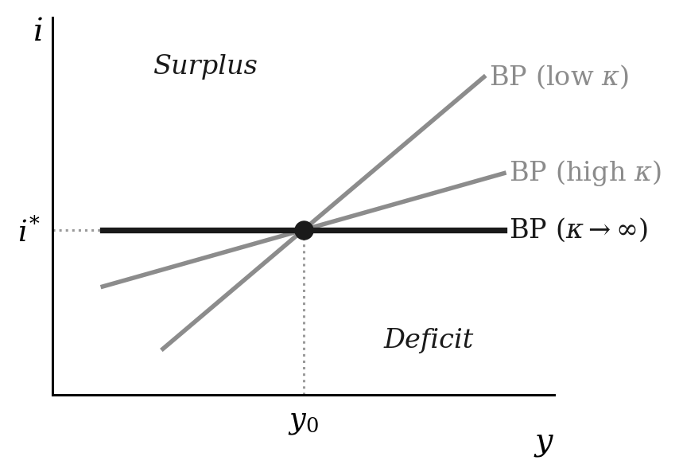
Figure 9. The BP curve. Higher capital mobility κ flattens it, and with perfect capital mobility it is horizontal at the world interest rate. Points above the curve are in surplus, points below in deficit.

5.5 Uncovered interest parity
Perfect capital mobility can be derived from investors’ choices. One unit of home currency held in a home bond for a period earns 1 + i_{t}. Converted into foreign currency instead, it buys 1/e_{t} units, earns 1 + i*_{t}, and is expected to convert back into (1 + i*_{t})E_{t}[e_{t+1}]/e_{t} units of home currency. Risk-neutral investors facing no barriers to capital flows hold only the bond that pays more, so in equilibrium the two returns are equal. Take logs, using ln(1 + i) ≈ i:
 | $$\begin{matrix}1+i_{t} & =\left(1+i_{t}^{*}\right)\frac{E_{t}\left[e_{t+1}\right]}{e_{t}} \\ i_{t}−i_{t}^{*} & ≈E_{t}\left[ln e_{t+1}\right]−ln e_{t}\end{matrix}$$ | (5.9)
This is uncovered interest parity (UIP): the home rate can exceed the world rate only if investors expect the home currency to depreciate by the difference. When no change in the exchange rate is expected it gives i = i*, the horizontal BP curve. Subtracting expected inflation at home and abroad from both sides turns it into a condition on real interest rates, using the definition of ε in (5.1):
 | $$\begin{matrix}\left(i_{t}−E_{t}\left[π_{t+1}\right]\right)−\left(i_{t}^{*}−E_{t}\left[π_{t+1}^{*}\right]\right) & =E_{t}\left[ln e_{t+1}−ln e_{t}\right]+E_{t}\left[π_{t+1}^{*}\right]−E_{t}\left[π_{t+1}\right] \\ r_{t}−r_{t}^{*} & =E_{t}\left[ε_{t+1}\right]−ε_{t}\end{matrix}$$ | (5.10)
Suppose investors expect the real exchange rate to be back at its equilibrium value ε̄ next period. A home real rate one point above the world rate then appreciates the real exchange rate by 1 per cent at once, so that the expected depreciation over the period exactly offsets the higher interest:
 | $$ε_{t}=\overset{‾}{ε}−\left(r_{t}−r_{t}^{*}\right)$$ | (5.11)

5.6 Mundell–Fleming: policy under perfect capital mobility
The Mundell–Fleming model asks what monetary and fiscal policy can do in the short run, with prices fixed at home and abroad, so that the real exchange rate moves one for one with the nominal rate. It adds a money market. Real money demand rises with output, by k, and falls with the interest rate, by h. On the LM curve it equals the real money supply M/P:
 | $$\begin{matrix}\frac{M}{P} & =ky−hi \\ i & =\frac{ky−M/P}{h}\end{matrix}$$ | (5.12)
With perfect capital mobility the economy must be on the BP curve, i = i*. Under a floating exchange rate the central bank chooses M and the exchange rate adjusts. Substituting i = i* into the LM curve pins down output:
 | $$y=\frac{M/P+hi^{*}}{k}$$ | (5.13)
Fiscal policy then cannot change output. A rise in government spending ΔG shifts the IS curve right and puts upward pressure on the interest rate. Capital flows in, the currency appreciates, and net exports fall until the IS curve is back where it started. By the second line of (5.6), with i fixed at i*, output is unchanged only if:
 | $$\begin{matrix}Δy & =\frac{ΔG+x_{1}Δε}{1−c_{1}(1−t)+m}=0 \\ x_{1}Δε & =−ΔG\end{matrix}$$ | (5.14)
Net exports fall by exactly the rise in government spending: full crowding out, through the exchange rate rather than the interest rate. Monetary policy, by contrast, is fully effective. A rise in M/P raises output through (5.13), and the currency depreciates by enough to raise demand to match:
 | $$\begin{matrix}Δy & =\frac{Δ(M/P)}{k} \\ x_{1}Δε & =\left[1−c_{1}(1−t)+m\right]\frac{Δ(M/P)}{k}\end{matrix}$$ | (5.15)
Under a fixed exchange rate the roles are reversed. The central bank must buy or sell whatever foreign currency keeps the exchange rate fixed, so it no longer chooses M: the money supply adjusts to keep i = i*. A fiscal expansion raises output by the full open-economy multiplier, because neither the interest rate nor the exchange rate can move to offset it. The money supply rises with money demand as the bank buys the foreign currency flowing in:
 | $$\begin{matrix}Δy & =\frac{ΔG}{1−c_{1}(1−t)+m} \\ Δ(M/P) & =kΔy\end{matrix}$$ | (5.16)
A monetary expansion achieves nothing. Buying bonds pushes i below i*, and capital flows out. To defend the exchange rate the bank sells foreign currency and buys back home currency until M returns to where it started. Under a floating exchange rate, then, monetary policy is fully effective and fiscal policy has no effect on output; under a fixed rate the reverse holds.
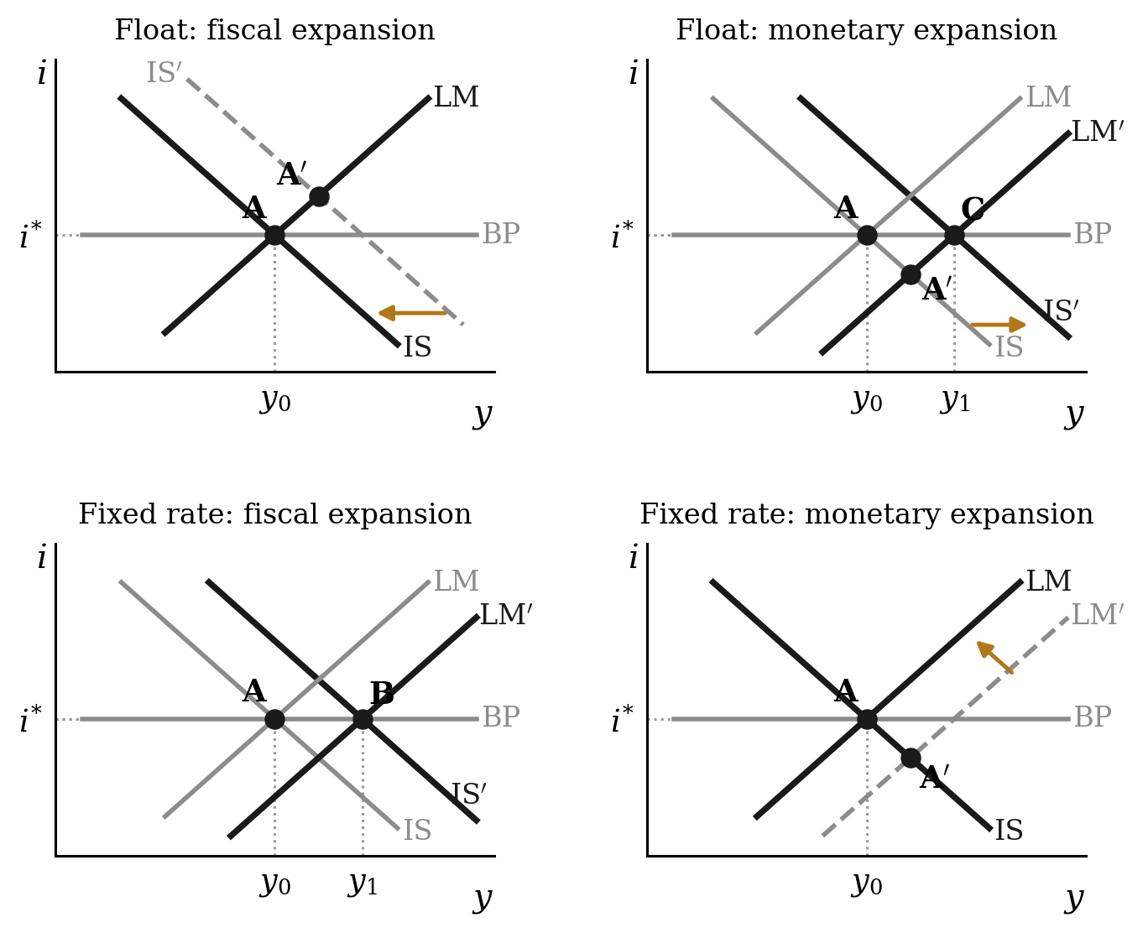
Figure 10. Policy under perfect capital mobility. Under a float, a fiscal expansion would take the economy to A′, but the appreciation it causes shifts the IS curve back to A; a monetary expansion pushes the interest rate down towards A′, and the depreciation it causes takes the economy to C. Under a fixed rate, a fiscal expansion is accommodated by a rise in the money supply (B), while a monetary expansion is reversed by capital outflows.

5.7 Imperfect capital mobility
When capital is imperfectly mobile, κ finite, fiscal policy under a float regains some power. A fiscal expansion raises output, and with M fixed the LM curve gives the rise in the interest rate, Δi = (k/h)Δy. The balance of payments (5.8) then determines how the exchange rate moves. Substitute both into the second line of the IS curve (5.6):
 | $$\begin{matrix}x_{1}Δε & =mΔy−κΔi=\left(m−\frac{κk}{h}\right)Δy \\ \left[1−c_{1}(1−t)+m\right]Δy & =ΔG−a_{1}Δi+x_{1}Δε \\ Δy & =\frac{ΔG}{1−c_{1}(1−t)+\left(a_{1}+κ\right)k/h}\end{matrix}$$ | (5.17)
Two limiting cases bracket the result. With no capital mobility, κ = 0, the float keeps trade balanced, the import leakage m drops out, and the multiplier is the closed-economy IS–LM one. As κ → ∞ the multiplier falls to zero, the Mundell–Fleming result. In between, the direction in which the currency moves depends on the slopes of the BP and LM curves, m/κ and k/h:
 | $$Δε<0\text{ if and only if }\frac{m}{κ}<\frac{k}{h}$$ | (5.18)
When the BP curve is flatter than the LM curve, the capital inflow drawn in by the higher interest rate exceeds the extra imports, and the currency appreciates. When it is steeper, the extra imports exceed the capital inflow and the currency depreciates. Perhaps surprisingly, a fiscal expansion can therefore weaken the currency when capital is not very mobile.
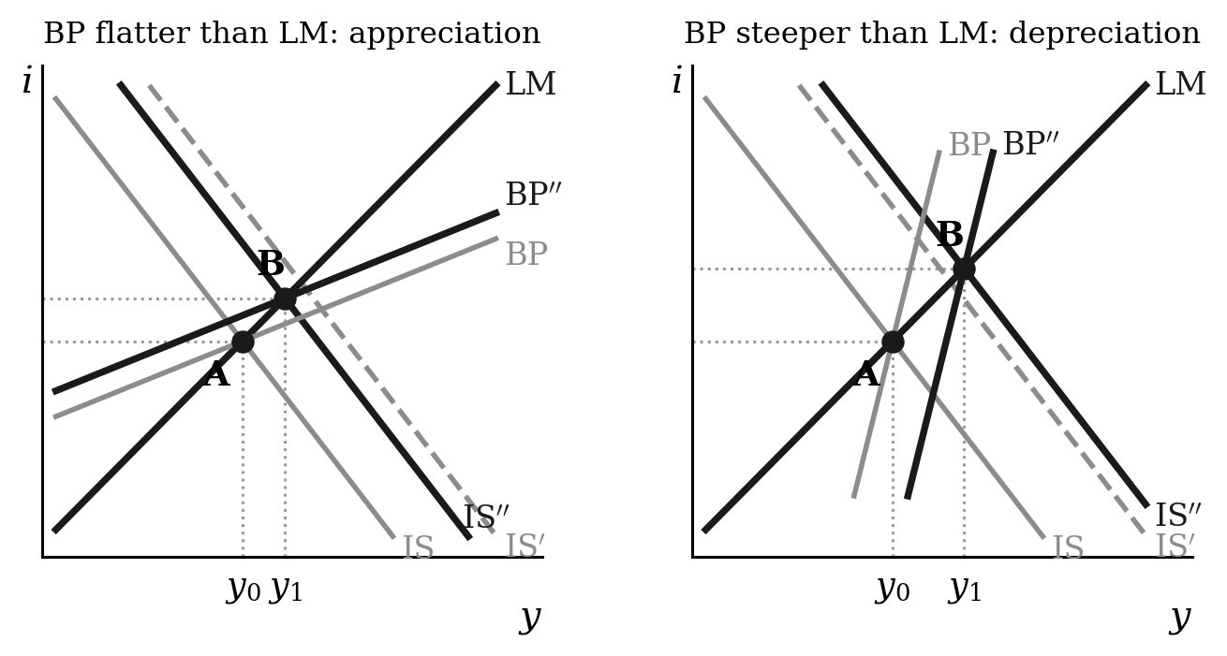
Figure 11. A fiscal expansion under a float with imperfect capital mobility. The IS curve shifts to IS′, and the exchange rate then moves it to IS″ and the BP curve to BP″, both passing through the new equilibrium B. The currency appreciates when the BP curve is flatter than the LM curve (left) and depreciates when it is steeper (right).

5.8 The three-equation model in an open economy
Return to a central bank that sets the interest rate to keep inflation at target, now with a floating exchange rate and capital mobile enough for real UIP (5.10) to hold. The home economy is small, so the world real rate r* is given. In equilibrium the real exchange rate is constant, so by real UIP the home real rate equals r*, and the real exchange rate takes the value ε̄ at which demand equals equilibrium output:
 | $$y_{e}=A−ar^{*}+b\overset{‾}{ε}$$ | (5.19)
The stabilising rate is now the world rate. In the closed economy it adjusted to whatever demand required; in the open economy it is pinned at r*, and the real exchange rate adjusts instead. The Phillips curve and the bank’s loss function are unchanged, so the monetary rule and the output gap rule (3.5) still hold. What changes is how the interest rate reaches output. Subtract (5.19) from the lagged IS curve (5.7) and use UIP in the form (5.11):
 | $$\begin{matrix}y_{1}−y_{e} & =−a\left(r_{0}−r^{*}\right)+b\left(ε_{0}−\overset{‾}{ε}\right) \\ ε_{0}−\overset{‾}{ε} & =−\left(r_{0}−r^{*}\right) \\ y_{1}−y_{e} & =−(a+b)\left(r_{0}−r^{*}\right)\end{matrix}$$ | (5.20)
A rate rise now works through two channels. It cuts investment, by a, and it appreciates the currency and so cuts net exports, by b. Eliminating r₀ − r* between the last two lines gives the RX curve, the combinations of output and real exchange rate that the bank can reach:
 | $$ε_{0}−\overset{‾}{ε}=\frac{1}{a+b}\left(y_{1}−y_{e}\right)$$ | (5.21)
Combine (5.20) with the output gap rule (3.5):
 | $$\begin{matrix}r_{0}−r^{*} & =\frac{θ}{a+b}\left(π_{0}−π^{T}\right) \\ ε_{0}−\overset{‾}{ε} & =−\frac{θ}{a+b}\left(π_{0}−π^{T}\right)\end{matrix}$$ | (5.22)
The bank needs a smaller rate change than in the closed economy, θ/(a + b) instead of θ/a, because the exchange rate amplifies each move in the interest rate. With a = b = 1 and α = β = 1, inflation 2 points above target calls for a real rate 0.5 points above the world rate, half the closed-economy response, and a real appreciation of 0.5 per cent. In this version an appreciation lowers inflation only by lowering output. In practice it also cuts import prices, and so consumer price inflation, directly, which strengthens the exchange-rate channel further.
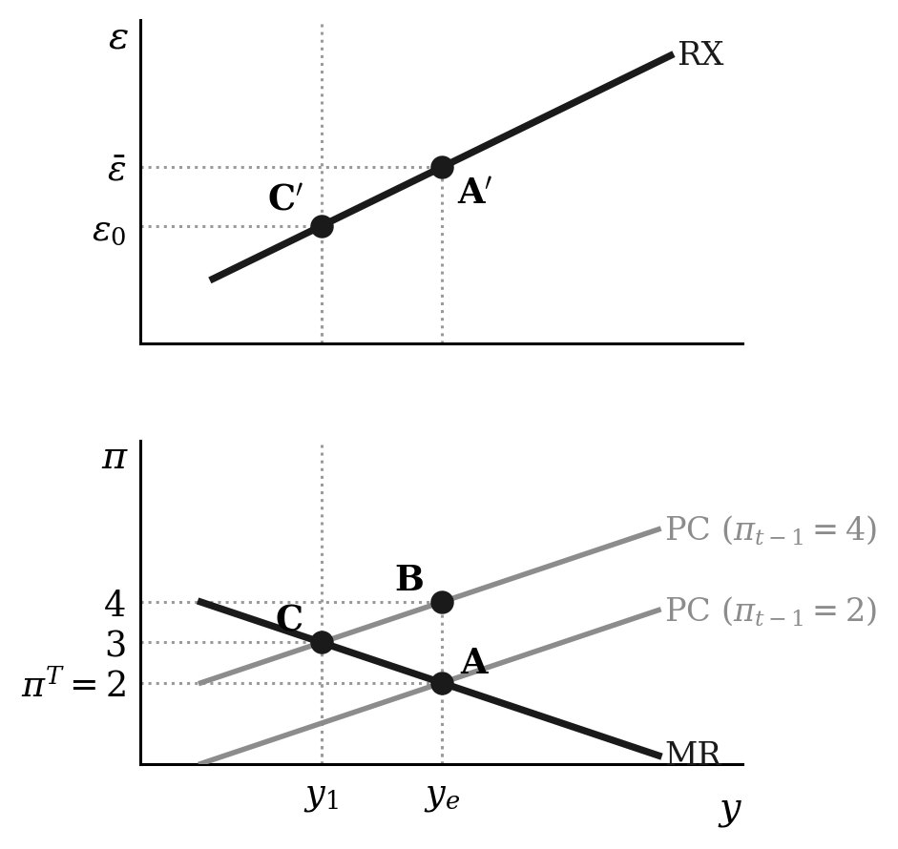
Figure 12. An inflation shock of 2 points in the open economy (a = b = α = β = 1). The bank chooses C on the MR line, and the real exchange rate appreciates to ε₀ on the RX curve (C′).

5.9 A permanent demand shock in an open economy
Demand rises by ΔA for good. The equilibrium real rate stays at r*, so by (5.19) the equilibrium real exchange rate must appreciate by enough to remove the extra demand:
 | $$\begin{matrix}y_{e} & =A^{′}−ar^{*}+b{\overset{‾}{ε}}^{′} \\ {\overset{‾}{ε}}^{′}−\overset{‾}{ε} & =−\frac{ΔA}{b}\end{matrix}$$ | (5.23)
Spending responds to the exchange rate with a lag, so output and inflation in period 0 rise as in the closed economy (4.2), by ΔA and αΔA. The bank raises the rate above r* to squeeze out that inflation, and the currency appreciates further on impact, now around its new equilibrium value. The last line splits the total appreciation into its permanent and temporary parts:
 | $$\begin{matrix}r_{0}−r^{*} & =\frac{αθ}{a+b}ΔA \\ ε_{0}−{\overset{‾}{ε}}^{′} & =−\left(r_{0}−r^{*}\right)=−\frac{αθ}{a+b}ΔA \\ ε_{0}−\overset{‾}{ε} & =−\underset{\text{permanent}}{\underbrace{\frac{ΔA}{b}}}−\underset{\text{temporary}}{\underbrace{\frac{αθ}{a+b}ΔA}}\end{matrix}$$ | (5.24)
Output and inflation follow the same path as in the closed economy, y₁ − y_{e} = −αθΔA, because the bank still follows the output gap rule. What differs is how the adjustment is shared. In the closed economy the stabilising rate rose permanently by ΔA/a, as in (4.3). Here the permanent adjustment is a real appreciation that crowds out net exports by enough to offset the extra demand, and the interest rate rises only while inflation is above target. This is the medium-run counterpart of the Mundell–Fleming result in Section 5.6: in a small open economy with mobile capital, a lasting rise in demand, including a fiscal expansion, is absorbed by the exchange rate.

